REMEMBER -LEAVING YOUR ABUSER | II. | STEPS TO TAKE BEFORE LEAVING | IV. | SAFETY WITH A PROTECTIVE ORDER | VI. | HEALTH AND EMOTIONAL WELL BEING
IS THE MOST DANGEROUS TIME.

- SAFETY PRIOR TO A VIOLENT INCIDENT

  - Keep the shelter or hotline phone number close at hand and keep some change or a calling card with you at all times for emergency phone calls.
  - Identify which doors, windows, elevator, or stairwell would be best. Practice how to get out of your home safely.
  - Decide and plan where you will go if you have to leave home (even if you don't think you need to).
  - Identify one or more neighbors you can tell about the violence and ask that they call the police if they hear a disturbance coming from your home.
  - Devise a code word to use with your children, family, friends, and neighbors when you need the police.
  - If a violent episode seems unavoidable, try to move into a room or area where you have access to an exit. Try to stay away from the bathroom, kitchen, and bedroom and anywhere weapons may be available.
  - Use your instincts and judgment. If the situation is dangerous, protect yourself by any means available, and then call the police as soon as possible. You have a right to protect yourself until you are out of danger.

You have the RIGHT to protect yourself until you are out of danger.

- Have a packed bag ready and keep it a trusted relative's or friend's home in order to leave quickly. The bag should contain items such as money, an extra set of keys, copies of important documents, extra medicine and clothes.
- Determine who would be able to let you stay with them or lend you some money.
- Open a savings account and/or a credit card in your own name to establish or increase your independence. Think of other ways by which you can increase your independence.
- Call your local shelter for further information, resources, and other safety precautions, and/or legal protective measures.
- Review your safety plan as often as possible in order to plan the safest way to leave your abuser. If you can safely do so, keep a journal of the abusive incidents.

- SAFETY IN YOUR HOME

  - Change the locks on your doors as soon as possible. Buy additional locks and safety devices to secure your windows.
  - Arrange to have an answering machine, caller ID, or a trusted friend or relative screen your telephone calls if possible.
  - Discuss safety with your children for those times when they are not with you (i.e., calling 911, not opening the door to the abuser, etc.).
  - Inform your children's school, day care, and/or caregivers about who has permission to pick up your children.
  - Inform neighbors that your partner no longer lives with you and that they should call the police if they see him/her near your home.
  - DO NOT open the door to your abuser. If safety is an issue, call 911.
- Keep your protective order with you at all times. Give copies to a trusted neighbor, relative, friend and a co­ worker.
- Call the police IMMEDIATELY if your partner breaks the protective order. Do not try to reason with your partner.
- Think of alternative ways to keep safe if the police do not respond right away (i.e., learn self-defense measures, etc.).
- Develop a supportive network of friends, family and neighbors. Inform them that you have a protective order in effect, that your partner no longer lives with you, and that they should call the police if they see them near your home.

- SAFETY ON THE JOB AND IN PUBLIC

  - Decide who at work to inform of your situation. This should include office or building security. Provide a picture of your abuser if possible.
  - Devise a safety plan for when you leave work. Have someone escort you to your car, bus, or train and wait with you until you are safely traveling. Use a variety of routes to travel home if possible. Think about what you would do if something happened while going home (i.e., in your car, etc.).
  - Notify agencies that have access to your home address, to not give your address or phone number to anyone, and request that they notify you if anyone tries to get that information.

- If you are thinking of returning to a potentially abusive situation, discuss other choices and alternatives with someone you trust.
- If you have to communicate with your partner for reasons such as child visitation, determine the safest way to do so (i.e., meeting in public place, meeting in the parking lot of police department, etc.).
- Plan to attend a woman's or victim's support group to gain support from others and learn more about yourself and the relationship.
- Decide who you can call or talk to freely and openly to give you the support you need.
- Develop positive thoughts about yourself and practice being assertive with others about your needs. Read books, articles, and poems to help you feel stronger.

You DO NOT deserve to be
hit or threatened!

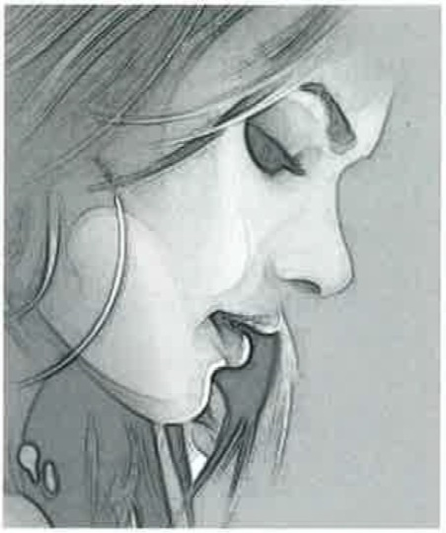

CHECKLIST
What you need to take when you leave.

IDENTIFICATION

Driver's License or other photo ID
Children's birth certificates
Your birth certificate
Social security card

FINANCIAL

Money and/or credit cards
Checkbooks
Bank account information
Proof of your partner's income

LEGAL PAPERS

The “Protection from Abuse” Order
Lease, rental agreement, house deed
Car registration & insurance papers
Health and life insurance papers
Medical records for you and your children
Work permits / Green card / Visa
Passport
Divorce papers
Custody papers

OTHER

House and car keys
Medications
Jewelry
Address book
Phone card
Pictures of you, your children & your abuser
Children's small toys
Change of clothes for you and your children

··:,

Crisis Line: 256-716-1000
www.csna.org

You have the

RIGHT

to be SAFE!

FOR MORE INFORMATION
Contact one of the following numbers:

24 HOUR EMERGENCY SHELTER AND OTHER SERVICES

HOPE Place - Domestic Violence Shelter
Crisis Line (In Madison County) 256-716-1000
(Outside Madison County) .......... 1-800-691-8426

Alabama Coalition Against Domestic Violence Statewide Hotline .......................1-800-650-6522

National Coalition Against Domestic Violence National Hotline.......................... 1-800-799-7233

COUNSELING
For survivors of abusive relationships and their families:

Crisis Services of North Alabama
(In Madison County) .256-716-1000
(Outside Madison County)..........1-800-691-8426

Domestic Violence Nurse Examiner, forensic exam (In Madison County) .256-716-1000
(Outside Madison County) ..........1-800-691-8426

Information & Referral for Social Services
From a land line 2-1-1
Or 1-888-421-1266

Rape Response Advocacy
Madison County .256-716-1000
Jackson & Limestone Counties..1-800-691-8426 Morgan County ..............................256-337-3670
Mental Health Association .256-353-1160

Rape, Abuse & Incest National Network
National Hotline .......................... 1-800-656-4673

Survivor Support Groups - Crisis Services of North AL Jackson County .256-574-5826
Limestone County .256-230-1240
Madison County ............................. 256-716-4052
Morgan County .............................. 256-337-3670

LEGAL ASSISTANCE
Lawyer Referral Service.......................1-800-392-5660 Legal Services Alabama Statewide…...1-866-456-4995 Limestone Family Resource Center……256-230-0880
Madison County ............................ ... ......256-536-9645
State of Alabama Child Support lnfo ..1-800-284-4347

Victim Witness Assistance, District Attorney's Office
Jackson County .................... ........ 256-574-9240
Limestone County .......................... 256-233-6416
Madison County ............................. 256-532-3460
Morgan County................................ 256-351-4610

LAW ENFORCEMENT ASSISTANCE

Emergency 9-1-1

Police Departments
Athens Police Dept......................... 256-233-8700
Decatur Police Dept. ...................... 256-353-2515
Gurley Police Dept. ....................... 256-776-3313
Huntsville Domestic Violence Unit.256-213-4538 Madison Police Dept......... ............256-722-7190
New Hope Police Dept. .................256-723-8443
Owens Cross Roads Police Dept. .256-725-4163 Scottsboro Police Dept..................256-574-3333

Sheriff's Department
Jackson County ............................. 256-574-2610
Limestone County 256-232-1530
Madison County ............................. 256-722-7181
Morgan County......................... 256-351-4800

DOMESTIC VIOLENCE VICTIM SERVICES AND COURT ADVOCACY

Jackson County .256-574-5826
Limestone County .256-230-1240
Madison County ...............................256-716-4052
Morgan County .............................. 256-337-3670
After Hours Advocate .256-716-1000

